horizontal line

Board Meeting

Date: Friday, 3-3-2017, AP&M

# Agenda

## Last Meeting Follow-up

1. Review minutes from last meeting (2-24-2017)
   1. Reminder: Who has taken on what responsibilities?
      1. Keenan: Publicity Chair?
      2. Aj, Aiden, Arkin: Food Planning?
2. Summary of major items:
   1. GBM Status and Updates
   2. Discuss plans for elections
   3. Finalize events

## New Business

1. GBM Updates
   1. Planning
      1. Timing and Date and room is final.
      2. If everything else is final, adverts should start going out next week.
   2. Logistics and roles
      1. Review: Who took on what roles at last week’s meeting?
      2. Updates from Committees:
   3. Outreach
      1. Do you have a description of the event?
      2. Flyer Design
         1. Needs review and final touches. Bring the flyer up, discuss
         2. Send to print on Saturday, distribute by next week
         3. What is the distribution plan?
      3. RSVP form: status?
      4. When is the Facebook event going up?
         1. Should go up as soon as rsvp form is finalized
      5. When is the website page + description going up?
         1. Can be done by me (Z.G.)
   4. Food Planning
      1. Has the food planning committee met?

Arkin said he’d work out a time to meet

* + 1. Have choices on style of food been made? What about the concrete location? Have you contacted any locations about catering, prices, delivery, etc?
    2. Taking into account food allergies - what allergies might people have? What food preference options did you add to the RSVP form?
    3. What is the budget? What are the relative costs/person for each option?
    4. About food planning
       1. List of options (on-campus) - difficulty level ★☆☆☆☆
          1. Round table pizza
          2. Rubios
          3. Panda
          4. Anything in pc that caters
       2. List of options (off-campus) - difficulty level ★★★★☆
          1. In-n-out
          2. Costco
       3. As per discussion on slack: many people consider Asian (ideally Indian) food to be a good choice.
  1. Content
     1. Why does SUMS exist?
     2. What do we tell people?
        1. Upcoming Events?
        2. Officer Positions?
        3. Election Plans?
     3. Need 2-3 major talking points

1. Plan Elections
   1. Need to review this, we covered a bit at the last meeting.
   2. What positions should be made available? What is their purpose? What are the terms? Responsibilities?
      1. Review officer positions: <https://drive.google.com/open?id=0B-o5ELumsfcpdnJrV1pMRFJNNFU>
      2. Note to anyone who holds a position now - try to document everything you are doing in your position right now. This way, it will be easy to onboard new people and explain responsibilities
   3. What is our recourse for officers who don’t work out?
   4. We need a plan completely nailed down before the GBM. If we’re confused, it’ll be confusing to everyone else.
2. Events
   1. Funding Requests for finalized events
      1. Ones that definitely need to go ASAP:
         1. Math Movie Night: Funding request status?
         2. May events: 2-4 weeks, depending (Review Calendar)
         3. Spring Lightning Talks: 4 weeks
         4. April Events: 4-5 weeks, depending
         5. Integration Bee: 5 weeks
   2. Math movie night:
      1. Need to decide on a movie soon, we probably want to mention the title at the GBM
      2. Also need some general ideas for structure, food, etc.
   3. Review events calendar
      1. Note: Open meeting next week to discuss structure for “freeform fridays”
   4. Goal: let’s finalize the rest of this year’s “official” events, book everything within the next few weeks, and get the funding requests in by Spring quarter.
   5. March Events
      1. Probably nothing for Pi day
      2. Everything else is booked
   6. April Events
      1. Review what people requested!
      2. Workshops: Ideas
         1. Some kind of coding
            1. R, numpy, octave, opengl
         2. 3D printing (esp. Parametric surfaces)
         3. Career workshop
            1. Talking to professionals (professors, analysts, data scientists, school teachers, engineers)
         4. Other ideas? Do members have workshops they want to do? Can we reach out to other organizations or faculty?
      3. Socials: Ideas
         1. Potluck
         2. Gaming night
            1. Board <<<<<<< my choice
            2. video
         3. Career talks/cafe night
            1. Hang out with people over some coffee and dessert
         4. Eating off-campus
      4. Integration Bee
         1. We should figure out a room for this ASAP.
         2. Forming committees - we should start figuring out who’s interested in what, don’t have to finalize yet:
            1. Funding requests and room booking

Probably a VP role?

* + - * 1. Food and Refreshments

Big event, so slightly more work

* + - * 1. Outreach and Publicity

Same as usual- flyers + social media

Also an opportunity to get staff involved

* + - * 1. Content and Organization

Come up with problems

Create matching/bracketing system

Keep track of judges and signups

* + - * 1. Roles for day of event

Volunteer judges, scorekeepers, timekeepers, food setup, cleanup

1. Website
   1. New website is up at [sums.ucsd.edu](http://sums.ucsd.edu)
   2. What do we do with [math.ucsd.edu/~sums](https://www.math.ucsd.edu/~sums/)
   3. Issue: old SUMS page has a **lot** of SEO traction, plus a sitemap(?) that makes 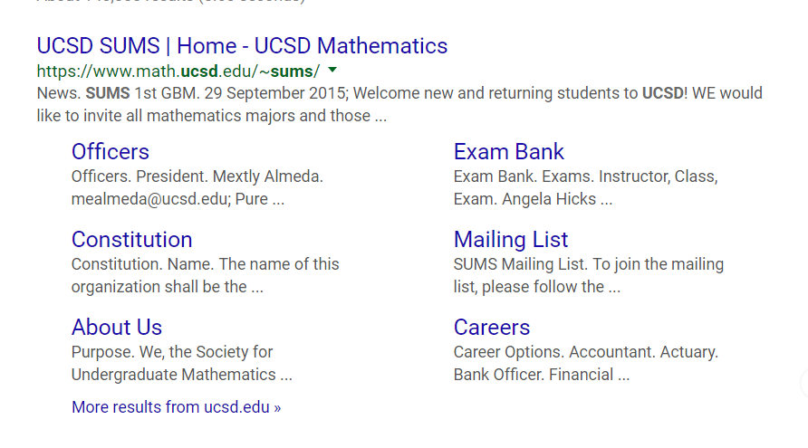the google result nicely formed:
      1. We don’t want to throw away our ranking, what can we do
         1. We can create a link from that page to ours. Or the other way. Whichever is the easier website to control.
   4. Content:
      1. We definitely need more, but the old content was **really** lame.
      2. Ideas?
         1. Contact us
         2. Brief intro (what we do)
         3. Event page
            1. Google calendar
         4. Why math major (career choices)
   5. Anyone who plans on ever doing edits needs to get on the Github org. Send Me (Zack) or Peter your github username to be added
      1. Plus, you’ll have to spend a few minutes with one of us to go over how content is edited, events are added, etc

# Notes

# Action Items

1. Finalize April events
2. Determine 2-3 simple, concrete, high-level messages we want to convey at the GBM
3. Make sure every member has deadline calendar

# Next Meeting Agenda Items

1. Finalize May and June events
2. Start forming 2017-2018 event calendar